  - HENNIKER HISTORIAN
  - June 2018 Number 72

Newsletter of the Henniker Historical society AND MUSEUM
Officers 2017-18  President: Kristen MacLean  Vice President: Diane Carpenter  Treasurer: Ron Taylor  Secretary/Newsletter: Ellen Reed  From the President  HHS board members have had some productive meetings this spring. Several repairs and operating improvements needed to be addressed.  It was determined during an annual inspection that the fire and security systems needed repair so we invested in a new system instead of spending more money on the old, part of which was recycled from the Fire Department.  It also came to our attention that the lattice work on top of the bell tower was askew. Thankfully, Martha was able to find the person who did the repair work in 1997. He and his son scaled the building and secured the lattice which had shifted in the wind.  After years of frustration dealing with our cataloguing program, we decided to purchase a new software program. Past Perfect is a user-friendly program designed for small museums. Soon we’ll begin scanning the first of our 5000 photos.  Also, I extend a very big “Thank You” to Gwen Airgood who has volunteered her time this year creating a new, soon to be revealed, web page.  I encourage everyone to participate in Henniker’s 250th town celebration. The society will be judging an 18th Century Costume contest at the beginning of the parade. We will have a booth at the Town Hall festivities. Be on the lookout for local artist, Andrea Parker, who is raffling off a gift basket with all proceeds going to the Henniker Historical Society. After the Town Hall festivities, HHS is sponsoring a talk (4pm Congregational Church Parish Hall) about Henniker’s most famous poet, Edna Dean Proctor and the slave Aunt Sallie.  There will be many family reunions happening August 3rd, 4th and 5th. Please pass all the TRUE stories regarding Henniker history to the folks at the society. Pray for excellent weather!  ~Kristen MacLean | Save the Date: Annual Meeting in June  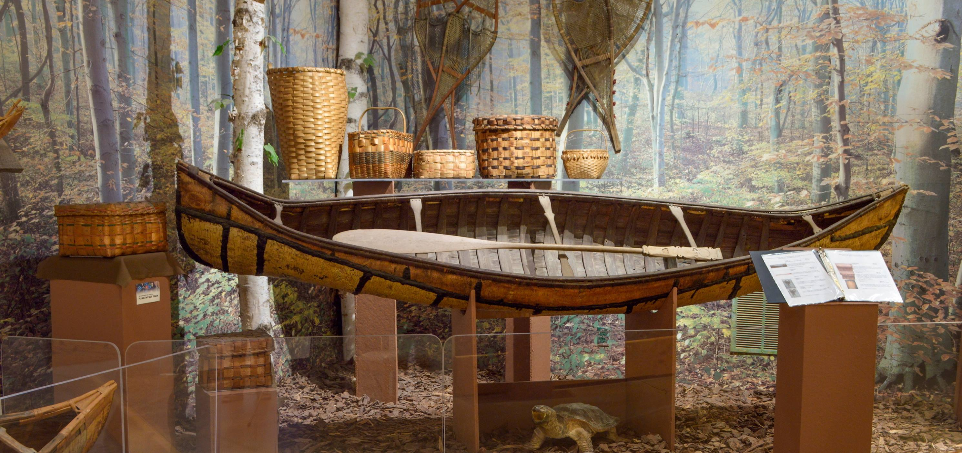  On June 20th, we will be holding our annual meeting and potluck at the Congregational Church Parish Hall at 5:30 pm. There will be a presentation by the Mt. Kearsarge Indian Museum. The presenter will be discussing artifacts from the museum, especially from the Northeast region. This should be a fascinating program, so don’t miss it! All members of the Henniker Historical Society are invited to attend. All we ask is you bring some food to share. We encourage all our members to become more involved in the Society!  Quilt Raffle  There is still time to purchase tickets for a quilt raffle! Two beautiful lap quilts made by local quilter, Peggy Gendreau will be raffled off during our Annual Meeting on June 20th. Tickets are $4 each or 5 for $15 and available at the Historical Society and Museum or through a board member.  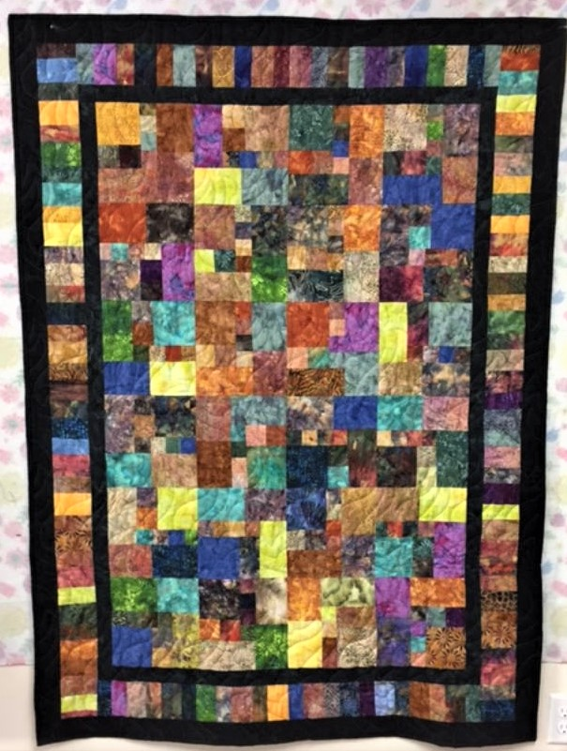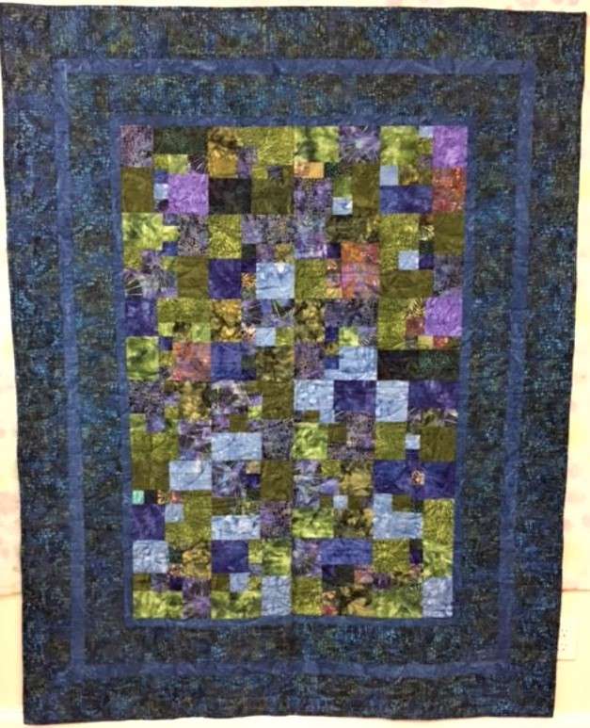
From Slavery to Freedom: A Live Performance  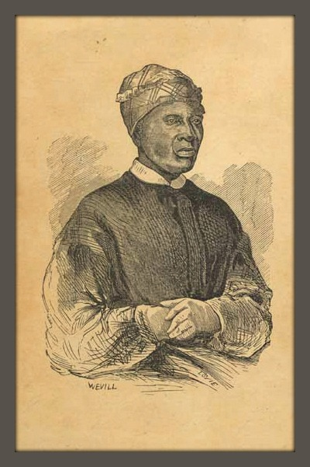  Storyteller Libby Franck will portray Edna Dean Proctor as an abolitionist and journalist who published Aunt Sally Williams’ slave narrative just 5 years after Uncle Tom’s Cabin was released. A well-known Civil War era poet, Proctor was born in Henniker in 1829.  After being enslaved on a NC rice plantation, Sally Williams was sold to a more lenient master and able to work as an independent entrepreneur. But the jealousy of her neighbors, both black and white, forced her back into the cruelties of slavery in Alabama. How Sally’s son bought her freedom through a network of literate slaves, and her delivery to Brooklyn, NY is as compelling today as it was in antebellum days.  Songs of the period will be sung by Adrienne Williams.  Don’t miss the opportunity to see this inspiring performance sponsored by the Henniker Historical Society.  Saturday, August 4th at 4 pm  Congregational Church Parish Hall, Henniker  Free Admission  Remember the Costume Contest  On August 4th, during Henniker’s 250th Celebration, HHS will be sponsoring an 18th Century Costume contest. It is open to all, including children, and the only requirement is that it be an outfit typical of the 1700’s, whether it be a frontiersman, lady of the manor, farmer or milkmaid, we’d love to see what you can come up with! | volunteers needed!  The Historical Society is always in need of volunteers to help us in our mission to preserve Henniker history. No experience is needed! New board members are also needed. So, if you have some spare time you’d like to donate, please contact Deb Dow at 491-6686.  VISIT US ON THE WEB:  www.hennikerhistory.org  email: society@mettelecom.com  Facebook  VISIT US AT ACADEMY HALL  51 Maple St  Henniker, NH 03242  603-428-6267  BUSINESS MEETINGS  Monthly board meetings are held the 2nd Wednesday of each month at 9 am in Academy Hall. Members and prospective members are invited to attend.  MEMBERSHIP  Your membership expiration is noted on your mailing list, if yours is about to expire please renew to continue to receive the newsletter and support us as we preserve Henniker history.  To renew, send $5.00 (checks can be made out to Henniker Historical Society) along with your name and address to:  Henniker Historical Society  PO Box 674  Henniker, NH 03242  SAVE THE DATE!  Henniker 250th Anniversary Celebration  August 3rd, 4th and 5th 2018
In honor of Henniker’s 250 anniversary, here is a reprint of an article written by Henniker historian and author of History of Henniker, NH, L. W. Cogswell for the Henniker Courier, December 15, 1904.

Early Settlers in Henniker
The desire for, and love of home is characteristic of all races and nations of people. However rude were the first home structures in this township, within were comfort and good cheer.
The houses of the first settlers were constructed of logs, the roofs of which were covered with thatch and bark. As soon as the mills were put in operation these gave way to larger and more substantial structures. In their houses, there were generally two square rooms in the front, the kitchen being in the rear, the roof reaching in many instances nearly to the ground. A huge fireplace occupied fully one-third of one side of the room into which great logs were rolled, which, when well lighted, made a cheerful blaze that illumed the whole room. Before this fire all the meals for the family were cooked, the bread being baked in tin or iron bakers. Potatoes were roasted in the ashes the meats cooked in the “tin kitchen” or turned upon the spit before the fire. Pine knots were the only light for many years. The floors were covered with sand and swept with hemlock brooms. There were no matches in those days and if the fire in the fireplace was allowed to go out the penalty was to go to some neighbors, perhaps a mile away, for a burning brand.
Their food was of the simplest kind. Rye meal bread and stewed pumpkins and milk constituted it largely, with boiled pork or beef and wild meats. For a change they sometimes had a basin of sweetened cider with toasted bread and cheese. On the Sabbath, the more fortunate ones had tea or chocolate for breakfast and doughnuts or pie. Milk was a great article of food in the summer.
These old settlers were hospitable, kind, devoted and full of humor of a genuine type. The meeting house and the minister always accompanied the settler. The old settlers of this town were strict adherers of the Sabbath, all work ceasing with the going down of the sun Saturday night, and everyone that could be spared from the home attended public worship where there was any service. Their religion was of the old Puritanical type and they were most intolerant to those whose faith did not sympathize with theirs. It was the custom to read the Bible morning and evening in many of the families whether professors of religion or not. In times of sickness their kindness was unbounded. When a death occurred in a population so small it cast a gloom over the settlement, and the bereaved family received the sympathy of all. All work ceased throughout the settlement until the body was buried. The exercises at the funeral consisted of a prayer and reading of the scriptures, and such a thing as a discourse at a funeral was unknown. The practice of serving liquors at funerals was observed in this town for more than half a century. All were seated and it was passed in small glasses. It is related that at one funeral in this town a century and a quarter ago it was feared the beverage would come short, when a sturdy old Scotchman, who was present from a neighboring town, sang out “Let ‘em all have a dram, and if there is nae enough I will get enough,” and the good old man was ready to make his word good for it soon transpired that he had brought a good supply with him.
The old settlers were mostly of a powerful frame and build, both men and women. Many of the women took their end of the log in the clearing of the land and could put a barrel of cider into a cart as readily as could the men. Many of the men were accustomed to shoulder a bushel of corn, carry it to Rumsford where St. Paul’s school now is, and return with the meal the same day.
The great game of all their gatherings such as log-rollings, raisings,and huskings for the men was wrestling matches in which hours were spent to show their skill and strength, and how close must have been their contests, such large, powerful, bony, withy men, “for they were giants in those days”.
The women had their gatherings as well as the men. All the cloth worn by men and women was manufactured in the home and home that did not have the spinning wheel, flax wheel and the loom was a rare sight. It was the delight of the women to meet at some neighbor’s, always carrying the flax wheel and the flax, and spend a portion of the day in social intercourse. The merits and demerits of all were discussed and the whole settlement was tried “as by fire in a crucible.”
The early settlers were great believers in signs, warnings, and premonitions. Settled as they were in the wilderness with few if any neighbors near them every sound almost seemed to them supernatural. From a grand-daughter (who passed away twenty-five years ago at the age of 90 years) of Capt. Jonas Bowman, one of the earliest settlers of this town on the banks of the Contoocook River, I have this fact, that one terrible windy, dark, stormy night Capt. Bowman was awakened from sleep by a loud rap upon his cabin door and a voice exclaimed ‘a man has been drowned in the river’. Mr. Bowman arose, lighted a pine torch, opened the door to his little cabin but no one was to be seen. He examined around the door outside but there were no foot prints visible. He entered his cabin, looked at the clock fingers of which pointed at twelve. Thinking it too dark and stormy, Bowman lay down again, but not to sleep. During the remainder of the night, he dwelled upon the strange voice he had heard. He arose with the early dawn and traveled to his three nearest neighbors, telling them his story and together they went to the ford of the river nearby, and there just below the crossing, the body of a man was found apparently drowned in an attempt to cross the river. The body was proven to be that of Nathan Reed of Hopkinton who was on his way to Hillsboro to visit friends.
Who can blame them for believing premonitions after witnessing such a scene as this.
L. W. Cogswell
HENNIKER HISTORY BOOK COMING SOON
A new history book, A Century in the Life of Henniker, New Hampshire, A Birdseye View of 1900-2000, with nearly 500 photos will be available at the 250th celebration. This is a great addition

NEW ITEMS IN THE MUSEUM

June is a great month to visit the Historical Society’s Museum. It is a warmup for this summer’s 250th Anniversary Celebration of the Town of Henniker. The Museum offers many chances to observe Henniker’s long and interesting history. New arrivals to the Museum include a handmade skirt, blouse and shawl from the 1800’s. The workmanship and detail of the outﬁt are exquisite. They belonged to Cora Swift Severance, grandmother of Debora Hooper. On the opposite spectrum of life in Henniker in early times are an oxen yoke and a farmer’s yoke for carrying buckets. These came from the Morse Family Farm by way of Bertha McComish. Of recent history is the quilt made and assembled by the students of Darby McGraw at Henniker Community School. Plan to spend a good block of time when you came to visit, as once you come into the Museum, it is very hard to leave. Prepare for the ﬂood of memories!

GIFT BASKET TO SUPPORT HISTORICAL SOCIETY AND MUSEUM
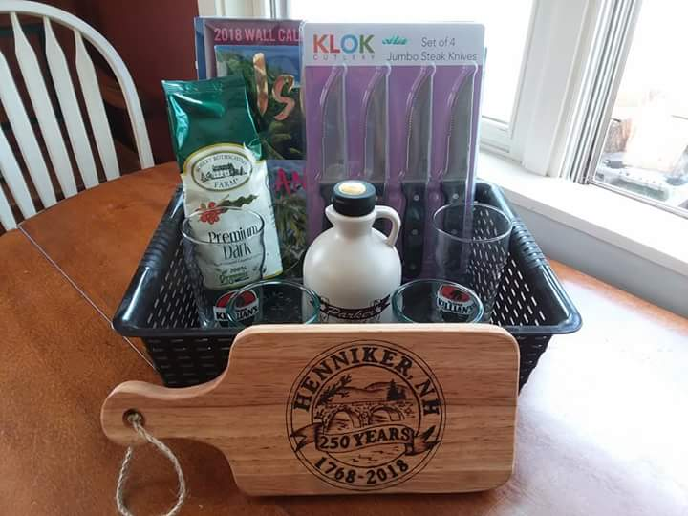
A lovely gift basket containing 3 -2018 calendars, set of 4 steak knives, coffee, 2 etched beer glasses, maple syrup and 2 Hemi glass drinking glasses with the double-sided 1 of 1 limited edition custom cutting board) will be on sale at the table of local artist, Andrea Parker at the Henniker 250th as well as at the Henniker Farmers Market will be raffled off, with all proceeds going to the Henniker Historical Society. The winner will receive the basket and its contents. Each ticket will be $5 winner will have to pick up in Henniker. The Henniker Historical Society would like to thank Andrea for her kind generosity and hope everyone will jump on this opportunity win one of her wonderful cutting boards!

SPECIAL NOTICE: THE HENNIKER HISTORICAL SOCIETY AND MUSEUM WILL BE CLOSED ON JULY 7TH AND SEPTEMBER FIRST FOR THE HOLIDAY WEEKENDS.

Can You Identify Any of These Photos?
People frequently donate old photos to the Henniker Historical Society, which is wonderful…except when they aren’t labeled! Trying to identify unknown people or places in photographs can be a daunting task, and we hope that someone might recognize the people in either of these two photos or the location of this barn. If you can give us any information, you can call us at Academy Hall at 603-428-6267 or email us at society@mcttelecom.com. Thanks!
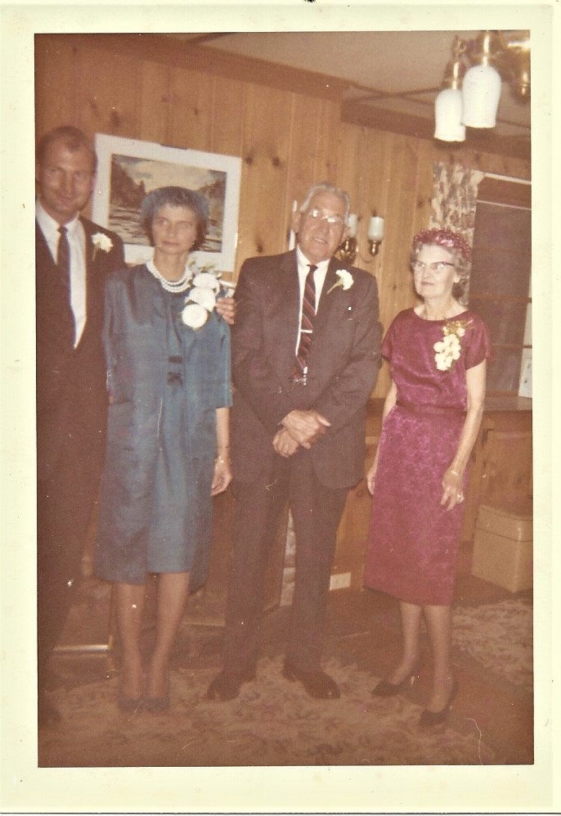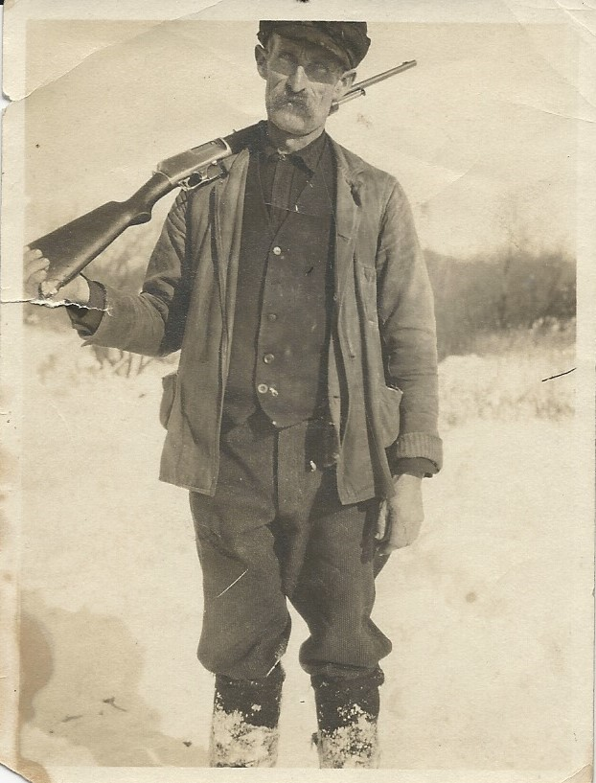

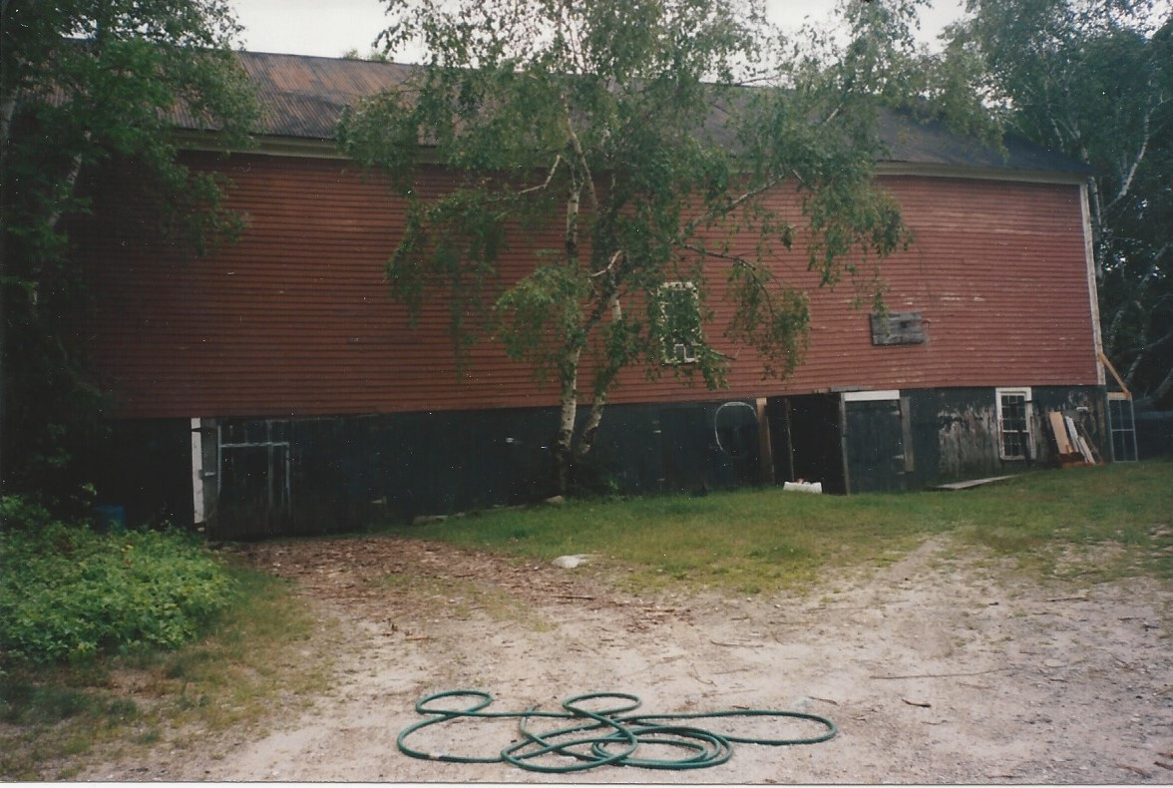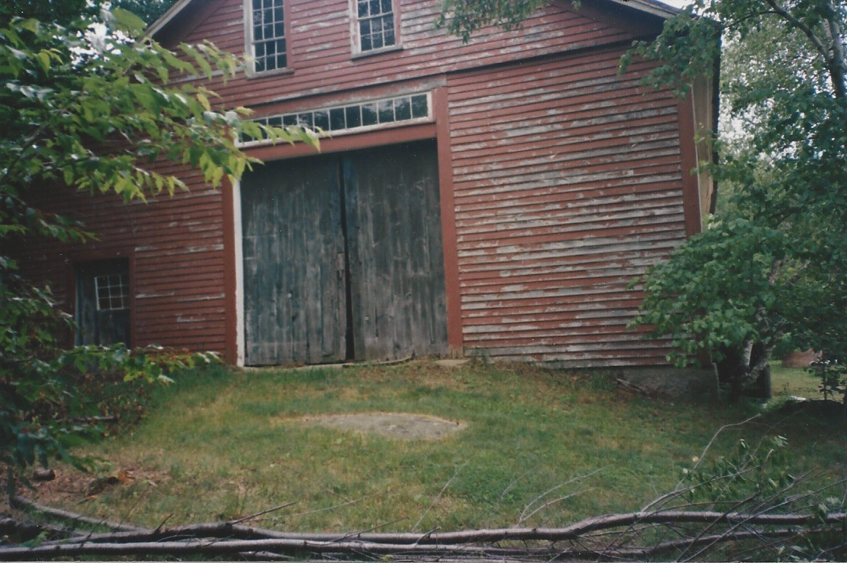

Henniker Historian
NON-PROFIT ORG.
US POSTAGE PAID
HENNIKER, NH
PERMIT NO. 35
Henniker Historical Society
PO Box 674
Henniker, NH 03242

June 2018 ADDRESS SERVICE REQUESTED
Newsletter
Issue No. 72

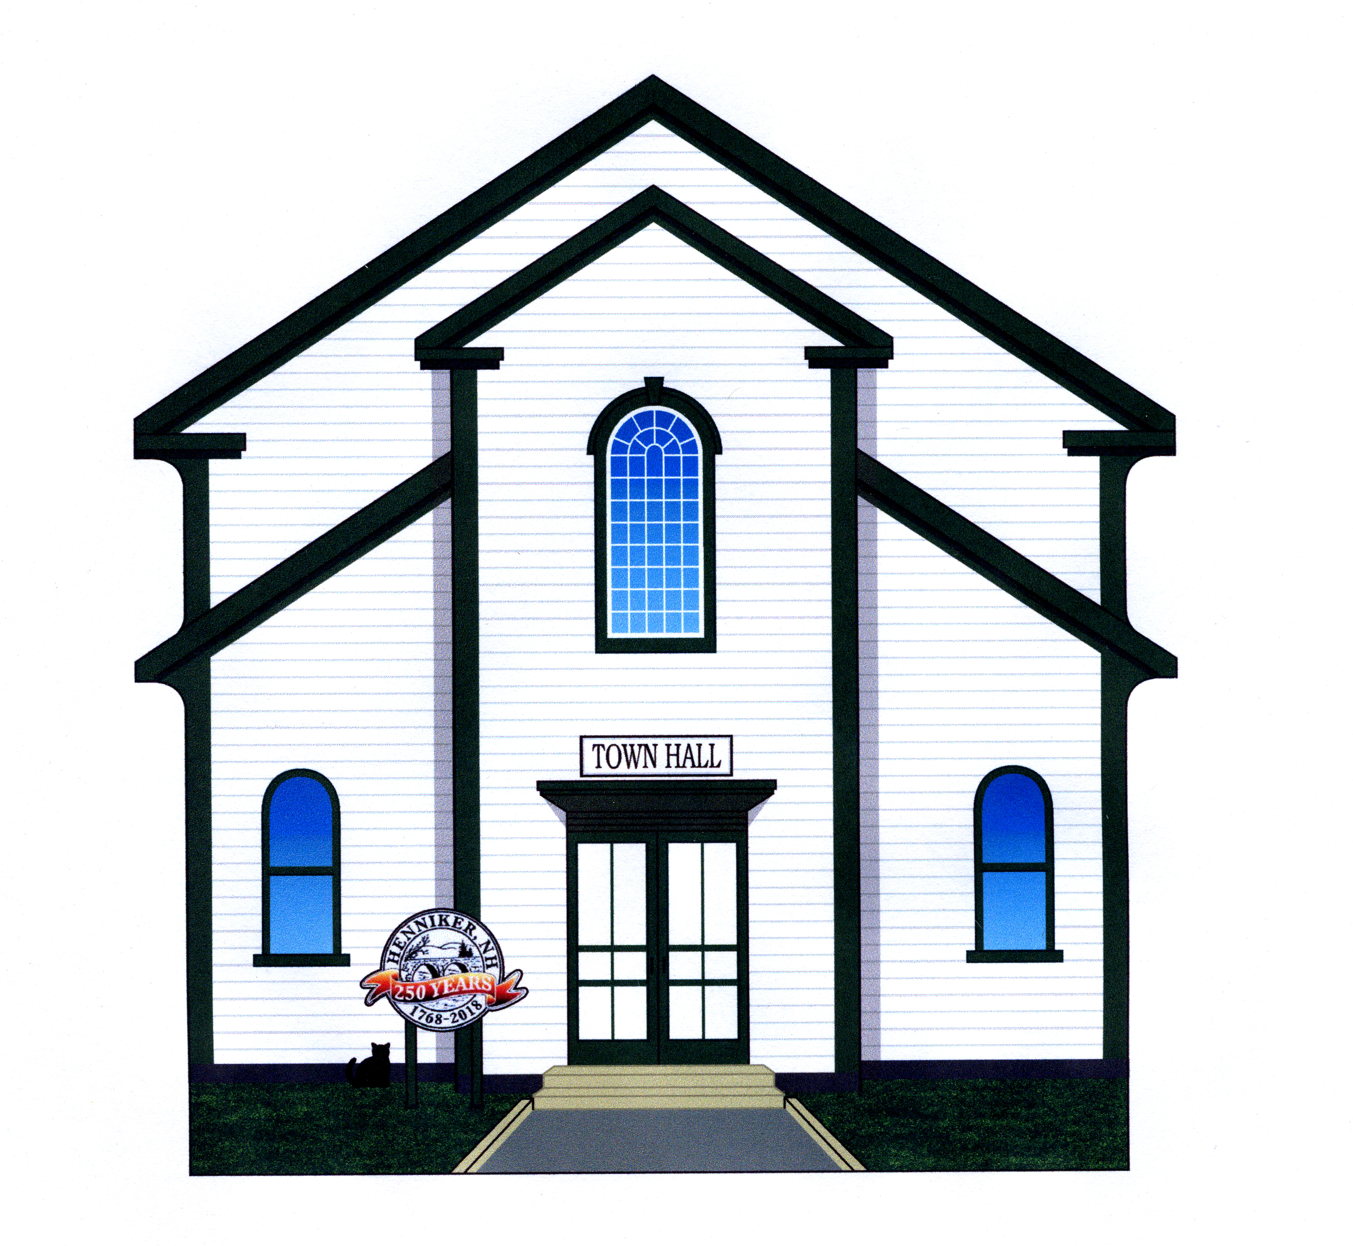
Commemorative Cat’s Meow Post Office Door Box Raffle
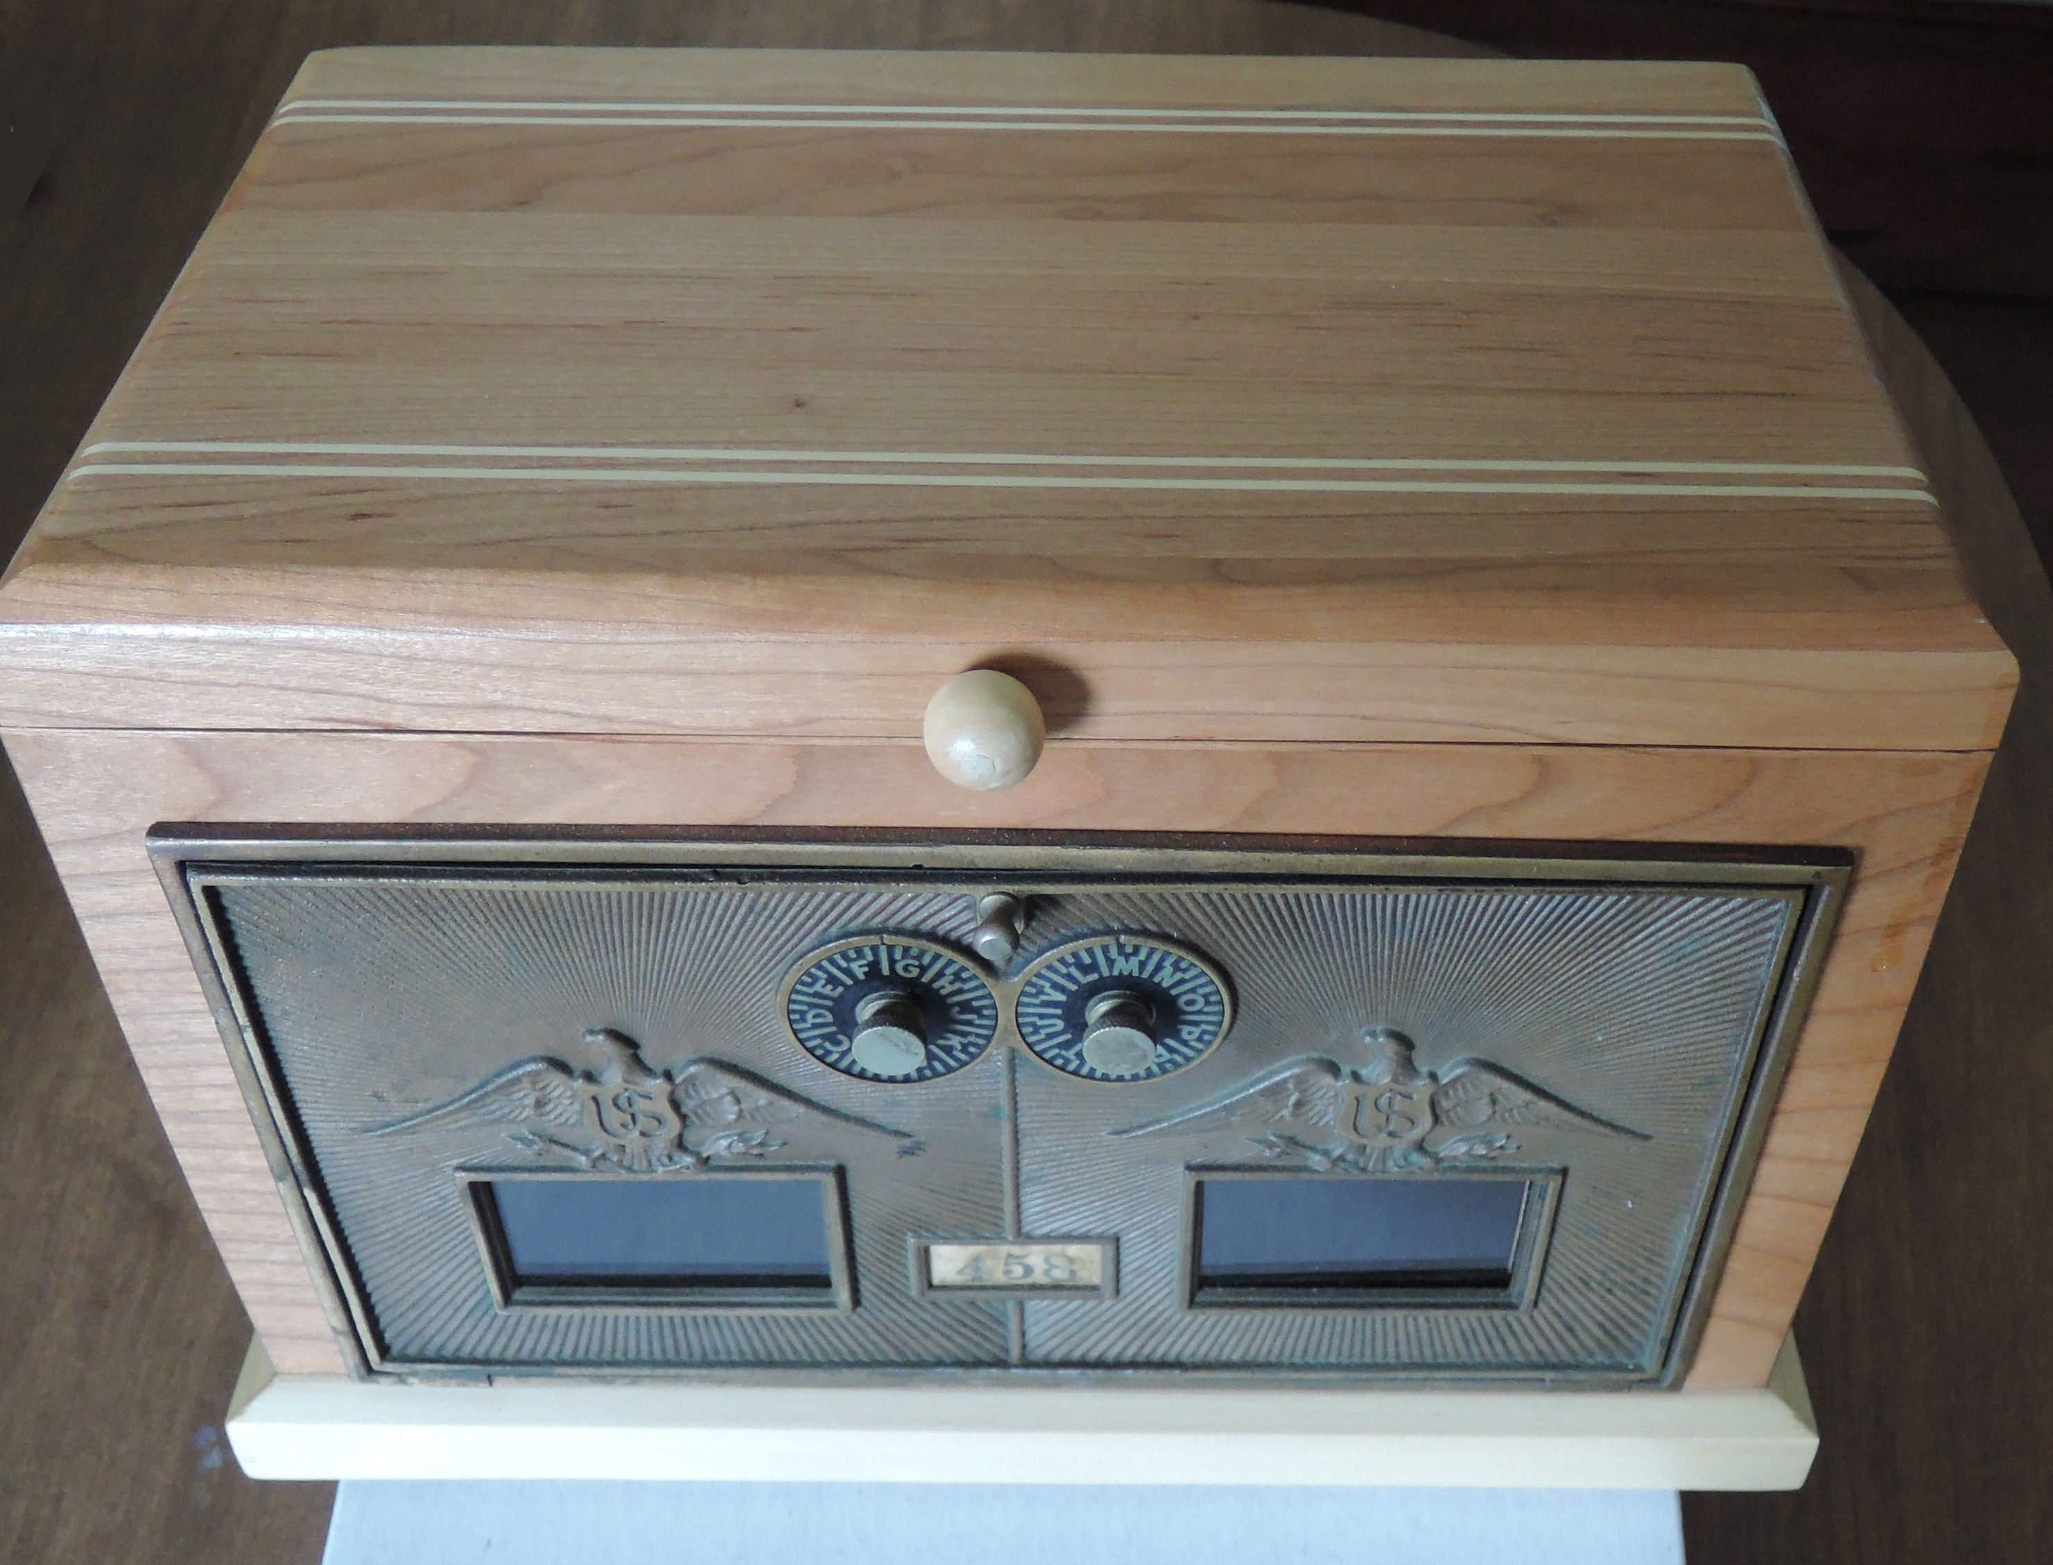

The Henniker Historical Society now has 250th commemorative Town Hall Cat’s Meows available for $20 at the Historical Society or the Henniker Pharmacy. We will also have new Cat’s Meows of the stone and covered bridges for sales. You will want them all for your collection!
At our booth at the 250th Anniversary celebration, we will be raffling off a beautiful handmade box featuring post office box doors from the old Rush Rd post office. Last spring, we had smaller versions made into banks. This one is considerably larger and opens at the top. We only have one available, so don’t miss out on this opportunity to obtain a piece of Henniker history.

